UofT SCS Data Analytics

Project 3

2019 February 23

# Project Proposal

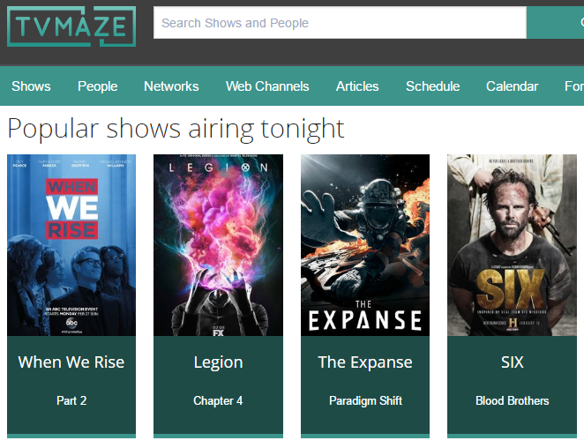

## Team Members

Swati Madan

Luciana BN

Suchitra Sharma

Dalia Dahleh

## Project Scope

Our group will be creating a web application that serves as a media library to keep track of tv shows that you would like to watch as well as the ones that you have watched already.

## Potential Data sets and Technologies to be Used

[Tv Maze API](https://datahelpdesk.worldbank.org/knowledgebase/articles/902061-climate-data-api)

MySQL

JavaScript, HTML, CSS

Flask

## Breakdown of Tasks

## Extracting data from TVMAZE API and pushing it into mySQL database.

## The database is then used to create an interactive webpage using Flask, Javascript and HTML.

**Research Questions to Answer**

What are the Top rated Tv shows of last month?

What are the most popular genres of TV shows made after 2015?

Create input field to search for tv shows and have image and other details show up

# Approval and Authority to Proceed

We approve the project as described above, and authorize the team to proceed.

|  |  |  |
| --- | --- | --- |
| Name | Title | Date |
|  |  |  |
|  |  |  |
|  |  |  |